EXPERIMENT 7
7 | Develop UML diagrams for an Online Security Management System that automates duty allocation, leave management, and salary calculation of security personnel. | Umbrello | CO1
Objective
To design UML diagrams for an Online Security Management System that automates duty allocation, leave management, and salary calculation of security personnel.
System Description (Short)
The Online Security Management System manages:
- Security personnel details
- Duty schedules
- Leave records
- Salary calculation
It automates manual processes for efficiency and accuracy.
PART 1 - CLASS DIAGRAM
Step 1: Open Umbrello
1. Open Umbrello UML Modeller.
2. Click File -> New.
Step 2: Create Class Diagram
1. Right-click Logical View.
2. Click New Diagram -> Class Diagram.
3. Rename the diagram as SecurityManagement_ClassDiagram.
Step 3: Create Classes
Create the following six classes:
1. SecurityStaff
2. DutySchedule
3. Location
4. Leave
5. Salary
6. Admin
Step 4: Add Attributes and Methods
Add the following attributes and methods to each class:
Class Name | Attributes | Methods
SecurityStaff | staffId, name, phone, designation | viewDuty(), applyLeave()
DutySchedule | dutyId, date, startTime, endTime | assignDuty(), updateDuty()
Location | locationId, locationName | updateLocation()
Leave | leaveId, leaveDate, reason | approveLeave()
Salary | salaryId, month, amount | calculateSalary()
Admin | adminId, name | assignDuty(), manageLeave(), generateSalary()

Step 5: Draw Relationships
Use association lines to connect the classes as follows:
From | To | Relationship
SecurityStaff | DutySchedule | Association
DutySchedule | Location | Association
SecurityStaff | Leave | Association
SecurityStaff | Salary | Association
Admin | SecurityStaff | Association

Step 6: Save Diagram
1. Click File -> Save or press Ctrl + S.
The Class Diagram contains six classes with their attributes, methods, and association relationships.
PART 1 - CLASS DIAGRAM
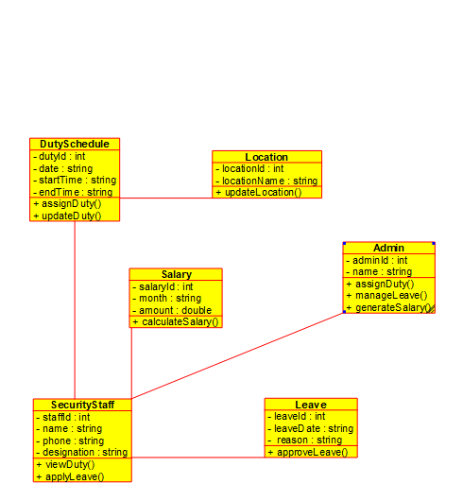
Figure 1: Class Diagram for the Online Security Management System.

PART 2 - USE CASE DIAGRAM
Step 1: Create Use Case Diagram
1. Right-click Use Case View -> New Diagram.
2. Rename the diagram as SecurityManagement_UseCaseDiagram.
Step 2: Add Actors
Add the following actors:
- Admin
- Security Staff
Step 3: Add Use Cases
Admin Use Cases:
- Assign Duty
- Update Duty
- Approve Leave
- Calculate Salary
- Generate Salary Report
Security Staff Use Cases:
- View Duty Schedule
- Apply Leave
- View Salary
Step 4: Connect Actors to Use Cases
- Connect Admin to Assign Duty, Update Duty, Approve Leave, Calculate Salary, and Generate Salary Report.
- Connect Security Staff to View Duty Schedule, Apply Leave, and View Salary.
Step 5: Save Diagram
1. Save the diagram in the SecurityManagement.xmi project using File -> Save.
The Use Case Diagram represents the functions performed by the Admin and Security Staff actors.

PART 2 - USE CASE DIAGRAM
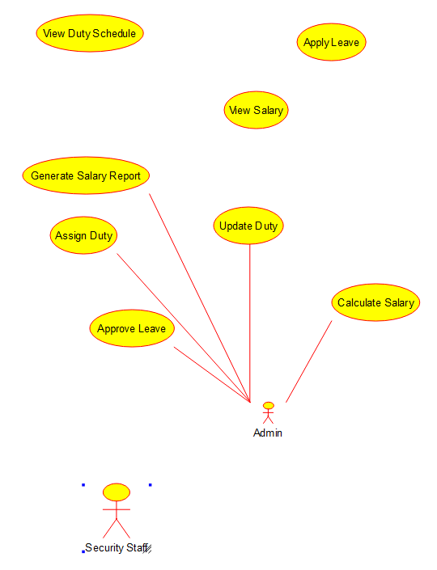
Figure 2: Use Case Diagram showing the Admin associations and the Security Staff actor.

PART 3 - ACTIVITY DIAGRAM
Step 1: Create Activity Diagram
1. Right-click Logical View -> New Diagram -> Activity Diagram.
2. Rename it as SecurityManagement_ActivityDiagram.
Step 2: Add Activities in Order
1. Start
2. Admin Assigns Duty
3. Security Staff Views Duty
4. Security Staff Performs Duty
5. Apply Leave (if required)
6. Admin Approves Leave
7. Monthly Duty Completion
8. Calculate Salary
9. Generate Salary
10. Security Staff Views Salary
11. Stop
Step 3: Add Decision Node
Place a decision node after Apply Leave with the condition:
Leave Approved?
- Yes -> Admin Approves Leave, then continues to Monthly Duty Completion.
- No -> Duty Continues, then joins Monthly Duty Completion.
Step 4: Connect All Activities with Arrows
Use control-flow arrows to show the sequence and connect both decision branches back to Monthly Duty Completion. Continue the flow through Calculate Salary, Generate Salary, Security Staff Views Salary, and Stop.
Step 5: Save Diagram
1. Click File -> Save or press Ctrl + S.

PART 3 - ACTIVITY DIAGRAM
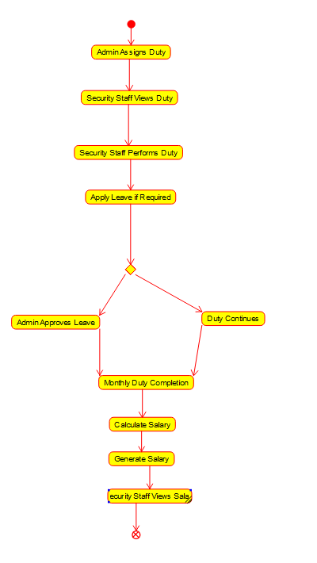
Figure 3: Activity Diagram showing duty allocation, leave decision, and salary workflow.
Result
Thus, the Class Diagram, Use Case Diagram, and Activity Diagram for the Online Security Management System were successfully designed using Umbrello UML Modeller.

